
Lesson 13: A Hit That Reacts
GameMaker
VIDEO GAME CREATION
This week: getting hit finally LOOKS like getting hit. A brief flash, then a small explosion, before the enemy disappears.
Open your own [YourName]Game project from Lesson 12 - don't start a new one.
Important: your score, lives, wave, and win/lose logic should all still work exactly as before. Today only changes how the enemy's removal LOOKS, not when your game-state actually changes.

Setup
- Open your [YourName]Game project from Lesson 12.
- Create a new object, obj_explosion, with a Sprite (import explosion_placeholder.png). In its Create event, set alarm[0] = 12. In its new Alarm 0 event, call instance_destroy() - it cleans itself up automatically.
- Import enemy_invader_white.png (this lesson's Assets folder) as a new sprite, spr_enemy_flash - it's the same enemy silhouette as obj_enemy's existing sprite, pre-recolored solid white, used below for the hit flash.

Level 1 - Minimal (MVP)
On every hit, the enemy briefly flashes, and a small independent explosion effect appears and cleans itself up. Score, lives, wave, and win/lose logic are all unaffected.
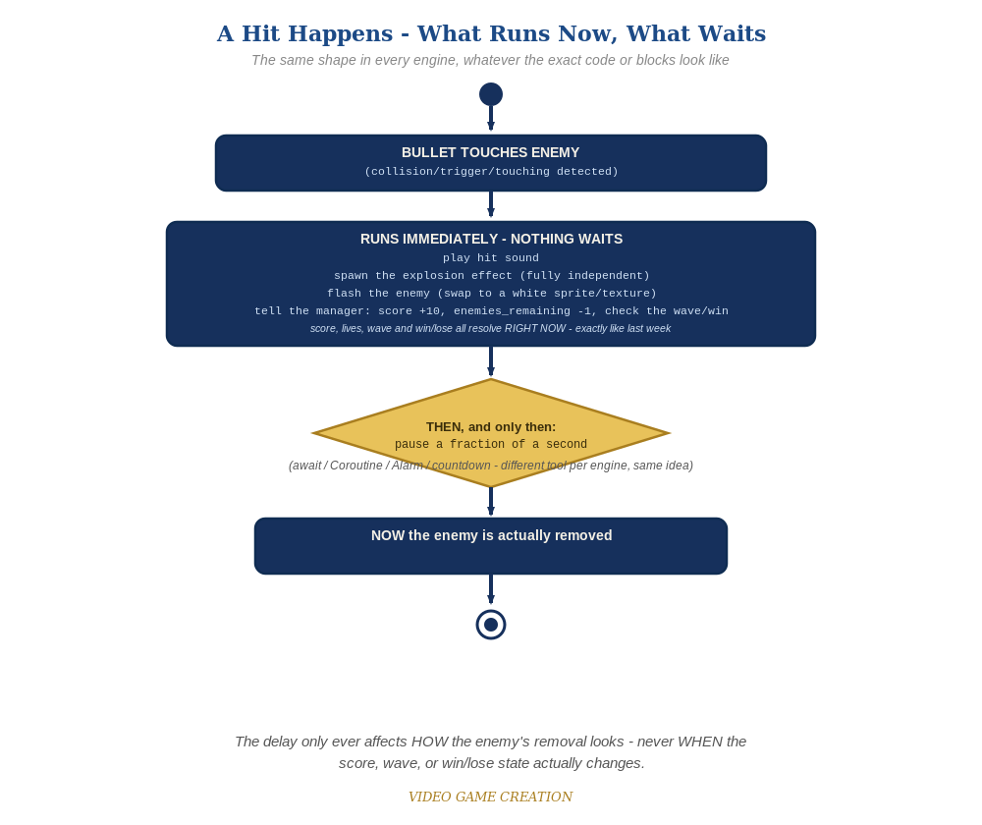
Everything in the top box happens the instant the hit is detected. Only the enemy's own removal - the very last step - waits for the pause to finish.
- GameMaker code can't pause mid-event, so this week's delay works differently: obj_bullet's Collision event starts the flash and sets an alarm on the enemy; a NEW Alarm 0 event on obj_enemy actually finishes removing it.
- On obj_bullet's Collision event with obj_enemy, right after the existing sound/score/win-check lines, add: instance_create_layer(other.x, other.y, "Instances", obj_explosion) (spawns the explosion immediately, independent of everything else), other.sprite_index = spr_enemy_flash (swaps to the flash sprite - image_blend won't work here, since it multiplies the sprite's existing color and multiplying any color by white leaves it completely unchanged, the same reason Lesson 2's Recolor swaps sprites instead of tinting them), and other.alarm[0] = 6.
- Remove instance_destroy(other) from obj_bullet's Collision event - the enemy is no longer destroyed here.
- Add a new Alarm 0 event to obj_enemy containing exactly one line: instance_destroy() - this is where the enemy actually disappears now, a fraction of a second after being hit.
- Press F5 (Run) and play through a full round - each hit should flash the enemy briefly, and a small burst should appear at that spot for a moment.
Highlighted lines are new this week; everything else is code you already have.
// obj_bullet Collision event with obj_enemy (revised):
audio_play_sound(sfx_hit, 1, false);
instance_create_layer(other.x, other.y, "Instances", obj_explosion);
other.sprite_index = spr_enemy_flash;
other.alarm[0] = 6;
obj_gamemanager.enemies_remaining -= 1;
obj_gamemanager.__dnd_score += 10;
if (obj_gamemanager.enemies_remaining <= 0) {
if (obj_gamemanager.wave >= obj_gamemanager.total_waves) {
obj_gamemanager.has_won = true;
obj_gamemanager.game_active = false;
audio_play_sound(sfx_win, 1, false);
} else {
obj_gamemanager.wave += 1;
obj_gamemanager.enemies_remaining = 5;
audio_play_sound(sfx_wave, 1, false);
spawn_enemies();
}
}
instance_destroy(self);
// obj_enemy's NEW Alarm 0 event:
instance_destroy();

Alternate Path: GML Visual (no typing)
The same collision-then-alarm pattern works as drag-and-drop blocks instead of typed code.
- On obj_bullet's Collision event (GML Visual), add a "Create Instance" block for obj_explosion, a "Set Sprite" block (Instance category) targeting other with Sprite = spr_enemy_flash (not a "Set Instance Variable" block on image_blend - a color tint can't produce a true white flash on a colored sprite), and a "Set Alarm" block for other.alarm[0], right alongside your existing score/sound blocks.
- Remove the "Destroy Instance" block that targeted the enemy, and add a new Alarm 0 event on obj_enemy with a single "Destroy Instance" block (targeting self).
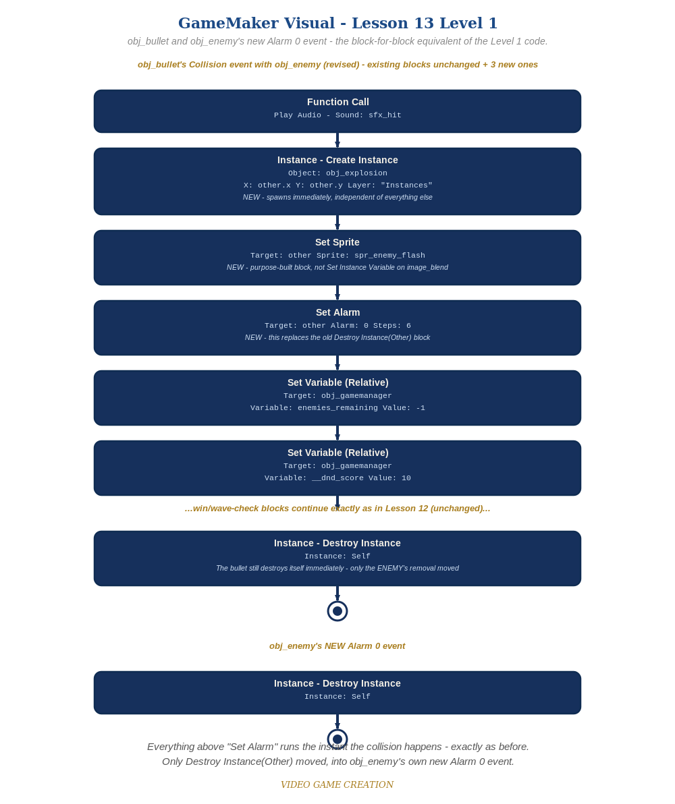
obj_bullet's Collision event and obj_enemy's new Alarm 0 event - the block-for-block equivalent of the Level 1 code.

Level 2 - Complete (Alpha/Beta)
The flash and explosion play correctly on every single hit, with no leftover explosions, no enemies stuck mid-flash, and no change to score/lives/wave timing.
- Play a full round: every single hit shows a flash and an explosion, with no enemy left stuck mid-flash.
- Confirm score, wave-clear, and win/lose all still happen at exactly the moments they did last week - only obj_enemy's actual removal is 6 steps later than before.
- Confirm obj_explosion instances never pile up - each one destroys itself via its own Alarm 0, with no help from obj_enemy.

Level 3 - Refined (Ready to Publish) - pick any that interest you
- Visual: instead of one flat instant swap, toggle sprite_index between spr_enemy_flash and the enemy's normal sprite every couple of steps across the 6-step alarm window, for a flicker instead of a single snap.
- Visual: grow obj_explosion's image_xscale/image_yscale from 0.5 to 1.5 across its Alarm 0 lifetime for an expanding-burst look.
- Structure: notice obj_explosion knows nothing about score, lives, or waves - it's a fully self-contained object, the same discipline as this course's bullets and enemies.

If Something's Wrong
- Enemy vanishes instantly, no flash visible: confirm instance_destroy(other) was actually removed from obj_bullet's Collision event, and that other.alarm[0] = 6 is set instead.
- Enemy disappears but never visibly turns white: confirm spr_enemy_flash was actually imported from enemy_invader_white.png and that other.sprite_index = spr_enemy_flash (not image_blend) is what's being set.
- Enemy never disappears at all: confirm obj_enemy actually has a new Alarm 0 event with instance_destroy() in it - setting an alarm does nothing without a matching Alarm event.
- "You Win!" or wave-clear timing feels off: it shouldn't - confirm score/enemies_remaining/win-check are still all inside obj_bullet's Collision event, unchanged, not accidentally moved into the new Alarm 0 event.

Want More?
Student Resource List > GameMaker section, or manual.gamemaker.io

